INSTALLATION INSTRUCTIONS
3” BENT END SIDE BAR
DODGE RAM 1500 02-08, RAM 2500/3500 REG AND QUAD CAB 03-09
PART NUMBER 1-0132 1-5132

PARTS LIST:

1 | Driver/Left Sidebar | 4 | 1/2" x 1-1/2" x 1/8" Flat Washers
1 | Passenger/Right Sidebar | 4 | 1/2" Lock Washers
2 | Front Mounting Brackets (Short) | 4 | 12-1.75mm x 120mm Hex Bolts
2 | Rear Mounting Brackets (Long) | 2 | 12-1.75mm x 40mm Hex Bolts
2 | Front Support Straps (02-05) W/2 Holes | 8 | 12mm ID x 32mm OD x 3 mm Flat Washers
1 | Driver/Left Front Support Bracket (06-08) with angled bend on end | 6 | 12mm Lock Washers
1 | Passenger/Right Front Support Bracket (06-08) with angled bend on end | 2 | 12mm Hex Nuts
2 | Rear Support Brackets w/90-degree bend on end (not used on regular cab models) | 4 | 10-1.5mm x 40mm Hex Bolts
4 | 10mm x 35mm Bolt Plates | 12 | 10mm ID x 30mm OD x 2.5mm Flat Washers
4 | Spacer Plates | 8 | 10mm Lock Washers
4 | 9mm Plastic Retainers | 8 | 10mm Hex Nuts
4 | 1/2" x 2" Hex Bolts

PROCEDURE:

- REMOVE CONTENTS FROM BOX. VERIFY ALL PARTS ARE PRESENT. READ INSTRUCTIONS CAREFULLY BEFORE STARTING INSTALLATION. DRILLING MAY BE REQUIRED.
- From underside the driver side front of the vehicle, remove the factory body mount bolt. Remove but do not discard the rubber bushing. Install (1) 12-1.75mm x 120mm Hex Bolt with (1) 12mm ID x 32mm OD x 3mm Flat Washer and (1) 12mm Lock Washer through the Driver Side Front Mounting Bracket. Position (1) Spacer Plate between the Mounting Bracket and the factory rubber bushing, (Figure 4). Slide the complete assembly up into position under the cab mounting bracket and thread the 12mm Hex Bolt into the factory mounting hole. Snug but do not tighten at this time.
- Next select the correct Front Support Bracket for your application.
2002-2005 Models.
Select the straight 2-hole Support Bracket. Attach one end to the side of the Front Mounting Bracket with (1) 10mm x 40mm Hex Bolt, (2) 10mm Flat Washers, (1) 10mm Lock Washer and (1) 10mm Hex Nut. Rotate the Support Bracket up to meet the factory body mount bracket and line up the hole in the body mount bracket with the Support Bracket, (Figure 1). Bolt the Support Bracket to the body mount bracket with (1) 12mm x 40mm Hex Bolt, (2) 12mm Flat Washers, (1) 12mm Lock Washer and (1) 12mm Hex Nut. NOTE: Some models may require drilling a mounting hole in the factory body mount bracket if not equipped.
IMPORTANT! Any cutting or drilling tool may break or shatter. Government regulations require safety glasses & equipment at all times when cutting or drilling.

2006-2008 Models.
Select the front Support Bracket with the angled end. Remove the sealing tape on the inner body panel to uncover the mounting location. Partially thread (1) 9mm Plastic Retainer onto a 10mm Bolt Plate. Insert the Bolt Plate into the mounting hole and thread

the Plastic Retainer down until it is flush against the body panel, (Figure 3). NOTE; The Plastic Retainer is designed to prevent the Bolt Plate from falling into the body cavity when properly installed. Secure the Support Bracket to the Bolt Plate with (1) 10mm Flat Washer, (1) 10mm Lock Washer and (1) 10mm Hex Nut. Attach the Support Bracket to the front-facing side of the Mounting Bracket with (1) 10mm x 40mm Hex Bolt, (2) 10mm Flat Washers, (1) 10mm Lock Washer and (1) 10mm Hex Nut, (Figure 5). Snug but do not tighten hardware at this time.
- Repeat Step 2 for the rear Mounting Bracket installation, (Figure 2).
- Next, select the rear Support Bracket (90-degree bend on one end). NOTE: The rear Support Bracket is not used on the Regular Cab models. Remove the sealing tape on the inner body panel to uncover the mounting location. Partially thread (1) 9mm Plastic Retainer onto a 10mm Bolt Plate. Insert the Bolt Plate into the mounting hole and thread the Plastic Retainer down until it is flush against the body panel, (Figure 3). NOTE; The Plastic Retainer is designed to prevent the Bolt Plate from falling into the body cavity when properly installed. Secure the Support Bracket to the Bolt Plate with (1) 10mm Flat Washer, (1) 10mm Lock Washer and (1) 10mm Hex Nut. Attach the Support Bracket to the front-facing side of the Mounting Bracket with (1) 10mm x 40mm Hex Bolt, (2) 10mm Flat Washers, (1) 10mm Lock Washer and (1) 10mm Hex Nut. Snug but do not tighten hardware at this time.
- Carefully unwrap the Sidebars and select the driver sidebar. Line up the end of the Sidebar with the front Mounting Bracket and secure with (1) 1/2" x 2" Hex Bolt, (1) 1/2" Lock washer and (1) 1/2" Flat Washer. Do not tighten hardware at this time. Repeat this step to bolt the Sidebar to the rear Mounting Bracket.
- Align and adjust the Sidebar then tighten all hardware.
- Do periodic inspections to the installation to make sure all hardware is secure and tight.
To protect your investment, wax this product after installing. Regular waxing is recommended to add a protective layer over the finish. Do not use any type of polish or wax that may contain abrasives that could damage the finish.
For stainless steel: Aluminum polish may be used to polish small scratches and scuffs on the finish. Mild soap may be used also to clean the Sidebar.
For gloss black finishes: Mild soap may be used to clean the Sidebar.

Driver Side Installation Pictured
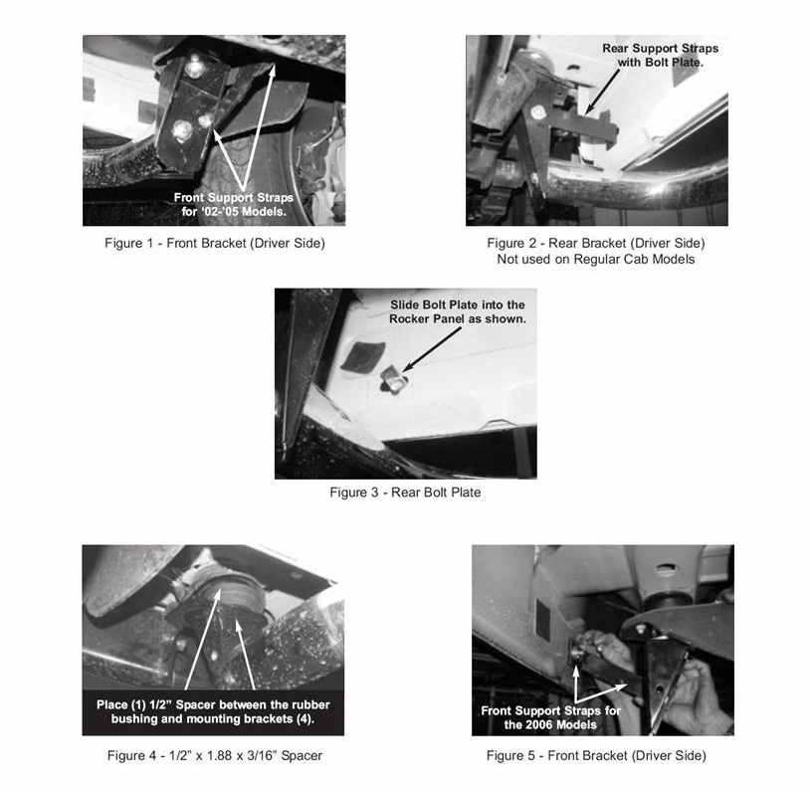

Plastic Retainer
