
RS-WP12A-Y, RS-WP12A-R, RS-WP12A-G
Wiring Diagram

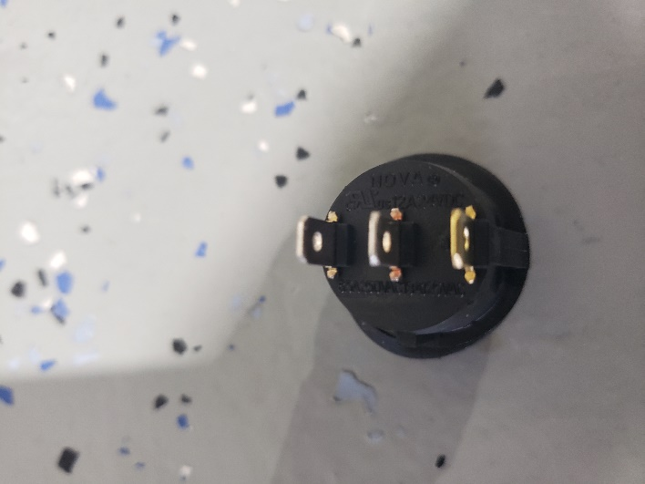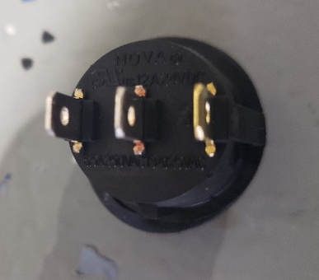
Outer Copper spade is you’re Ground wire
Middle spade is you’re output side
Top spade is you’re 12 volt or ignition
