

WF920 Series – Combination Winter Front and Bug Screen

INSTALLATION INSTRUCTIONS

IMPORTANT NOTE: THE BUG SCREEN MUST BE USED AS THE TEMPLATE

Before installing Stick A Stud ^{TM *D*} fasteners, please note:

- Clean area with isopropyl alcohol swab (supplied)
- Surface must be completely dry, wax free with no cleaning fluid present.
- For best results, install at temperatures over 60ºF (16ºC). Use a hair dryer to
warm up the surface and the Stick A Stud™ ^{*D*} if necessary.
- The base of the Stick A Stud™ ^{*D*} can be shaped by bending or folding along the indented lines

FOR CONCAVE OR CONVEX SURFACES FOR ANGLED SURFACES
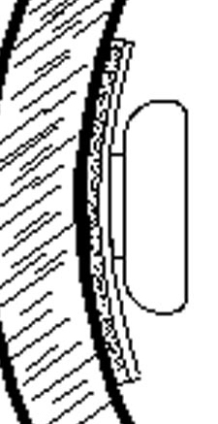
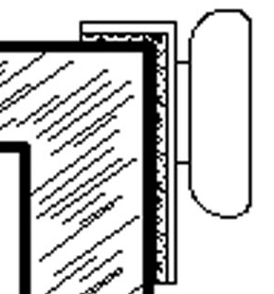

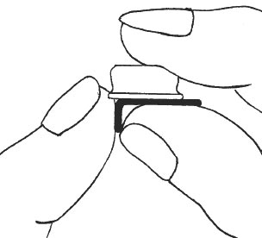
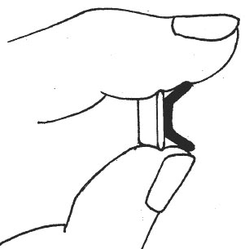

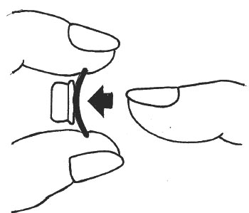
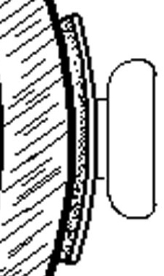

- In some instances the Stick A Stud ^{TM *D*} fastener’s base may require trimming. Simply cut as required
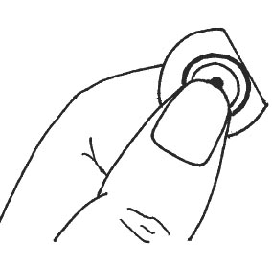
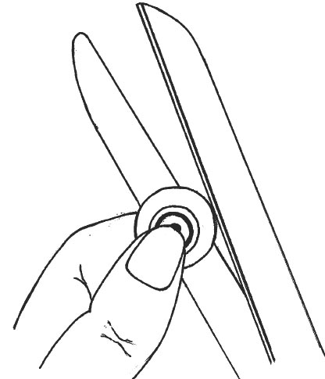

INSTALLATION:
- Snap all Stick A Stud ^{TM *D*} fasteners to the bug screen while ensuring the protective backings remain intact.
- Position the bug screen on the vehicle and note where each Stick A Stud ^{TM *D*} fastener will be located to ensure there will be maximum surface contact at each installation point.
- Temporarily fasten the bug screen with masking tape to the vehicle.
- Remove protective backing from a corner Stick A Stud ^{TM *D* .} Avoid touching adhesive.
- Apply firm pressure for 10 seconds.
- Apply the next Stick A Stud ^{TM *D*} fastener ensuring that no stress is applied to other fasteners when installing the bug screen. CAUTION: A MINIMAL AMOUNT OF STRESS ON THE BUG SCREEN FROM SIDE TO SIDE AND TOP TO BOTTOM IS RECOMMENDED. EXCESSIVE STRESS WILL CAUSE IMPROPER INSTALLATION.
- Attach remaining Stick A Stud ^{TM *D*} fasteners along top and bottom.
- Carefully remove bug screen and again apply firm pressure to each Stick A Stud^{TM *D*} fastener. INSTANT BOND CAN BE INCREASED BY USING HAIR DRYER ON HIGH FOR 2-3 MINUTES ON EACH INSTALLED STUD.
- Allow a minimum of 24 hours before use. See chart on reverse.

BOND STRENGTH
TIME | BOND
20 minutes | 50%
60 minutes | 75%
24 hours | 90%
72 hours | 100%

Additional Stick A Stud ^{TM *D*} fasteners are available; part number HK104
They are also available in white; part number HK108
Kits with studs and screws are also available; part number HK103

NOTES

- Models requiring adhesive velcro installation:
BEFORE APPLYING VELCRO:
- Ensure the area where velcro strips are to be attached is clean and dry.
- Remove protective backing
- Secure in place by pressing firmly on velcro
Step 2-B: Attach adhesive backed velcro strip to the underside of the grill frame to line up with velcro on bug screen. On some vehicles the adhesive backed velcro strips require mounting on the front of the grill frame or under the hood on the radiator frame.

- Models requiring attachment to grill face and bumper for installation:
WF921-24, WF924-6, WF926-7, WF927-3, WF929-34, WF929-48, GS901-24, GS904-6, GS906-7, GS907-3, GS909-34, GS909-48

- Models requiring attachment to the top of the grill frame under the hood and to the bumper: WF925-7, WF927-32, WF927-33, WF929-45, GS905-7, GS907-32, GS907-33, GS909-45

- Models requiring attachment to the hood: WF921-17,WF921-19, WF921-20, WF921-21, WF923-4, WF925-42, WF929-281, WF929-46, GS901-17, GS901-19,
GS901-20, , GS901-21, GS903-4, GS905-42, GS909-281, GS909-46

- Models requiring attachment to grill face and to top of the grill frame under the hood: WF921-15, WF921-16, WF922-9, WF924-11, WF924-12, WF924-7, WF924-8, WF925-6, WF925-71, WF926-81, WF926-9, WF929-22, WF929-26, WF929-361,
WF929-42, WF929-43, GS901-15, GS901-16, GS902-9, GS904-11, GS904-12, GS904-7, GS904-8, GS905-6, GS905-71, GS906-81, GS906-9, GS909-22, GS909-26, GS909-361, GS909-42, GS909-43

- On some models there are more domes than are required for installation. Align unit with grill to determine which domes are required.

Should you require further information on installing this product, please contact our
customer service department at:

Fia Inc. Winnipeg, Canada R3L 0N3
Telephone (204) 475-0515 Toll-Free: 1-800-835-0438
Fax: (204) 284-8246 E-Mail: info@gofia.com Website: www.gofia.com

06-22-12

